Batch:______A3____ Roll No.:____1911034__________
Experiment No. 7
Grade: AA / AB / BB / BC / CC / CD /DD

Title: Implementation of Graph traversal menu driven program (DFS and BFS).

Objective: To understand graph as data structure and methods of traversing Graph

Expected Outcome of Experiment:

CO | Outcome
CO3 | Demonstrate sorting and searching methods.

Books/ Journals/ Websites referred:

https://www.geeksforgeeks.org/graph-data-structure-and-algorithms/
https://jeffe.cs.illinois.edu/teaching/algorithms/book/05-graphs.pdf
https://www.hackerearth.com/practice/algorithms/graphs/breadth-first-search/tutorial/

Abstract:- (Definition of Graph, types of graphs, and difference and similarity between graph & tree )

Definition of Graph :
- In computer science, a graph is an abstract data type that is meant to implement the undirected graph and directed graph concepts from the field of graph theory within mathematics.
- A graph data structure consists of a finite (and possibly mutable) set of vertices (also called nodes or points), together with a set of unordered pairs of these vertices for an undirected graph or a set of ordered pairs for a directed graph. These pairs are known as edges (also called links or lines), and for a directed graph are also known as arrows. The vertices may be part of the graph structure, or may be external entities represented by integer indices or references.
- A graph data structure may also associate to each edge some edge value, such as a symbolic label or a numeric attribute (cost, capacity, length, etc.).
Example of a graph :
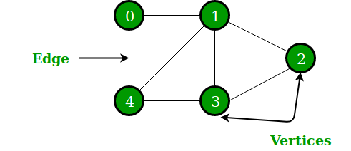

Types of Graphs :

1. Weighted Graph
Graphs whose edges or paths have values. All the values seen associated with the edges are called weights. Edges value can represent weight/cost/length.
Values or weights may also represent:
- Distance covered between two points- Ex: To look for that shortest path to the office, the distance between two workstations in an office network.
- Speed of the data packet in a network or bandwidth.

2. Unweighted Graph
Where there is no value or weight associated with the edge. By default, all the graphs are unweighted unless there is a value associated.

3. Undirected Graph
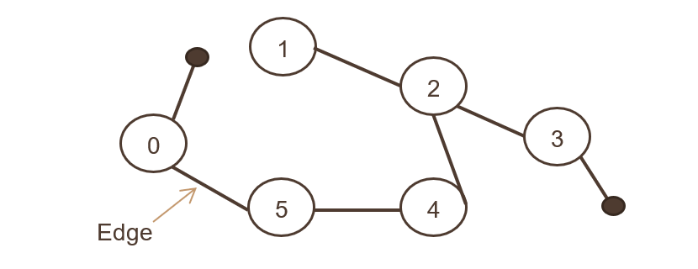
Where a set of objects are connected, and all the edges are bidirectional. The image above showcases the undirected graph,

4. Directed Graph
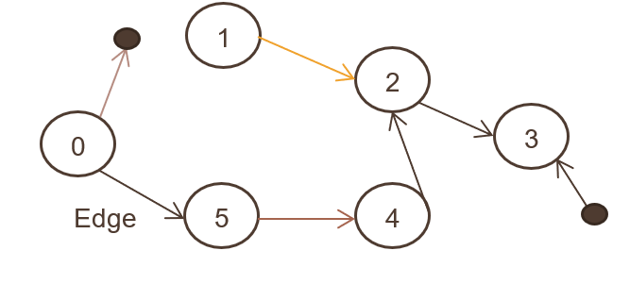
Also called a digraph, where a set of objects (N, E) are connected, and all the edges are directed from one node to another. The above image showcases the directed graph.

Differences and Similarities between Graphs and Trees:
Similarities :
- Both graphs and trees are non linear data structures.
- Both graphs and trees are a collection of vertices (nodes) and edges
- A Tree is actually one of the special cases of the graph data structure.

Differences between graphs and trees are as follows :
- In a tree , there is a unique node called as the root , whereas in a graph , there is no such unique node.
- In a graph , a cycle can be formed, while in a tree , cycles will not be formed.
- A tree is a less complex structure having three traversal techniques , namely in order , pre order and post order. While a graph is a more complicated structure having two search techniques , namely , breadth first search and depth first search.

Algorithm for DFS:
Note : In the algorithm ,(and code ), DFS is implemented as a recursive function, and we assume that we have already formed the graph by taking the elements and the links between them from the user.
Step 1: In the recursive function , pass the three parameters , namely the element to start the DFS , the adjacency matrix of the graph and the visited array.
Step 2: For each node , passed as the parameter , repeat the step 3 as given below.
Step 3: Mark the current node as visited in the visited array, print the node , and visit all the adjacent and unmarked nodes of that node by checking for a ‘1’in the row of the current node in the adjacency matrix . ( as a value of 1 indicates that there is a link between current node and that node).
Step 4: Traverse all the other nodes in a similar manner.
Step 5: if all nodes have been traversed , then all the values in the ‘visited array’ will be 1. Else , we backtrack and visit all the unvisited nodes in a similar manner.

Algorithm for BFS:
- A queue (FIFO-First in First Out) data structure is used by BFS.
- You mark any node in the graph as root and start traversing the data from it.
- BFS traverses all the nodes in the graph and keeps dropping them as completed.
- BFS visits an adjacent unvisited node, marks it as done, and inserts it into a queue.
- Removes the previous vertex from the queue in case no adjacent vertex is found.
- BFS algorithm iterates until all the vertices in the graph are successfully traversed and marked as completed.
- There are no loops caused by BFS during the traversing of data from any node.

Program Source Code :
#include <stdio.h>
void DfsTraversal(int,int[20],int a[20][20]);
void BfsTraversal(int fe, int ar[20], int a[20][20],int q[20],int r, int f) ;

int main(void) {
int n,i,el,j,k,ele,fe,ch;
printf("enter the number of vertices\n");
scanf("%d",&n);
int a[20][20];
int ar[20];
for (int i = 0; i < 20; i++)
for (int j = 0; j < 20; j++)
a[i][j] = 0;
for(i=0;i<20;i++)
{
ar[i]=0;
}
printf("enter the neighbours of each of the vertices\n");
for(i=0;i<n;i++)
{
printf("enter the number of neighbours of element %d\n",i);
scanf("%d",&k);
printf("enter it's neighbours\n");
for(j=0;j<k;j++)
{
scanf("%d",&ele);
a[i][ele]=1;

}
}
printf("adjacency matrix\n");
printf(" ");
for(i=0;i<n;i++)
{
printf("%d ",i);
}
printf("\n");
for(i=0;i<n;i++)
{
printf("%d ",i);
for(j=0;j<n;j++)
{
printf("%d ",a[i][j]);
}
printf("\n");
}

printf("enter the element to start the traversal from\n");
scanf("%d",&fe);
printf("enter 1 for DFS Traversal or 2 for BFS Traversal\n");
scanf("%d",&ch);
if(ch==1)
{
printf("DFS TRAVERSAL\n");
DfsTraversal(fe,ar,a);
}
else if(ch==2)
{

int q[20];
for(i=0;i<20;i++)
{
q[i]=0;
}
printf("BFS TRAVERSAL\n");
BfsTraversal(fe,ar,a,q,-1,0);
for(i=0;i<=n;i++)
{
if(a[i])
printf("%d\t", i);
}
}

return 0;
}

void DfsTraversal(int fe, int ar[20],int a[20][20])
{
int i;
ar[fe]=1;
printf("%d\t",fe);
for(i=0;i<20;i++)
{
if((a[fe][i]==1)&&(ar[i]!=1))/*it may be the case that an element is the neighbour of another element , but if it has already been traversed then we need to check for it in the single dimensional array*/
{
DfsTraversal(i,ar,a);
}
}

}

void BfsTraversal(int fe, int ar[20], int a[20][20],int q[20],int r, int f) {
int i;

for(i = 1; i <= 20; i++)
if((a[fe][i]==1)&&(ar[i]!=1))
q[++r] = i;
if(f <= r) {
ar[q[f]] = 1;
f++;
BfsTraversal(q[f],ar,a,q,r,f);
}
}
Screenshots of Output :
DFS Traversal
Graph used :
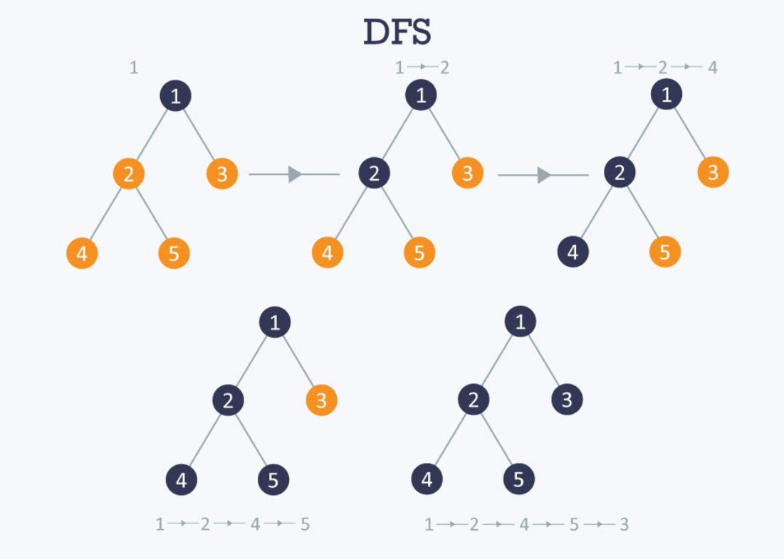

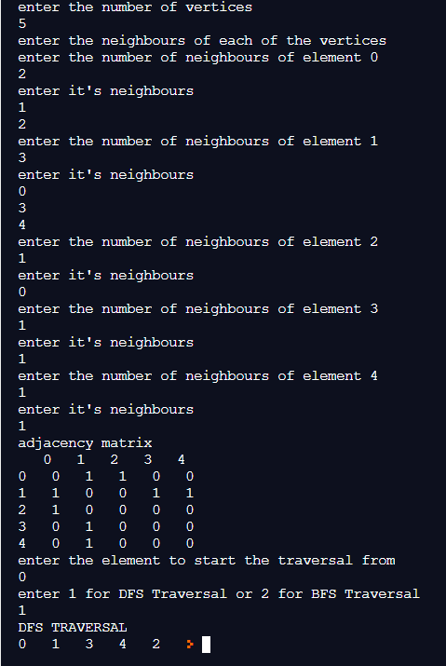

BFS TRAVERSAL
Graph used :
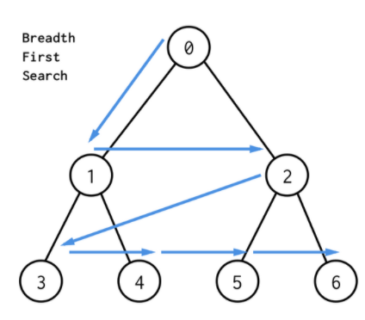

Output :
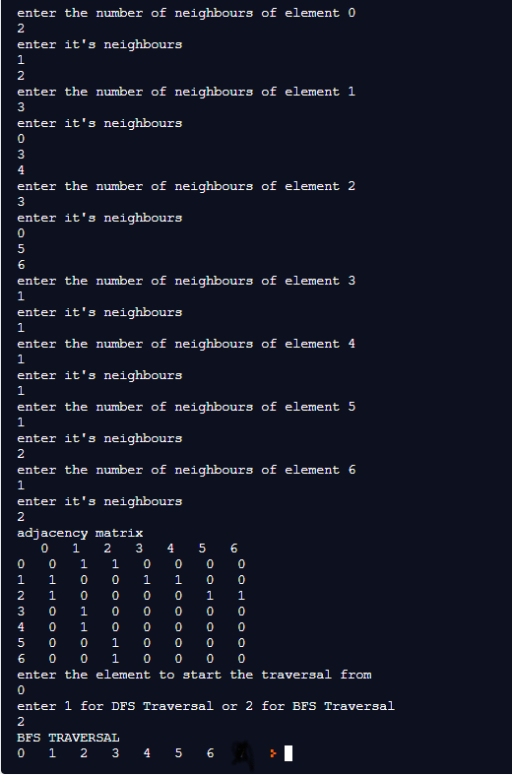

Implementation Details:
- Enlist all the Steps followed and various options explored

Steps followed :

- Initially we accept the graph from the user , by initially asking for the number of elements.
- We then create an adjacency- matrix representation of the graph by putting a ‘1’ in the column and row of any element pair that are linked to each other.
- This adjacency matrix gives us the full representation of the graph.
- We then ask the user to enter 1 for DFS Traversal or enter 2 for BFS Traversal.
- According to the choice entered by the user , we either pass control to the BfsTraversal or DfsTraversal function.
- Then we use a recursive algorithm to find the DFS/BFS traversal of the graph , and print it.

Options explored :

- In creating the adjacency matrix , the number of neighbours of each element indicated by the number of columns of each row can be created either by implanting a two dimensional array , or by allocating nodes dynamically , as a linked list , here we have implemented using array.
- We have also provided the user an option to enter any number of elements , (less than 20) , for which the graph , and thus the adjacency matrix is created.

- Explain your program logic, classes and methods used.

Logic of program :

- Accept the number of elements to be entered in the form of an adjacency matrix ( algorithm given below).
- For each node in the graph , using DFS/BFS traversal as described above , traverse the node and print it’s value , by calling the DFS/BFS function recursively.
- For each visited node , mark it’s value in the visited array as 1.
- The algorithm is complete , when all nodes have been traversed , i.e, all nodes in the visited array have been marked as ‘1’.

Logic for implementation of adjacency matrix
- Initially , we take a two dimensional matrix and initialize the number of rows and number of columns equal to the total number of elements
- We then initialize all the elements of the matrix to 0.
- For each row , in the adjacency matrix , which represents the individual element , we ask the user for the number of neighbours , and mark each neighbour as a 1 in the matrix .
- Therefore in the adjacency matrix , a ‘1’ exists in the row and column of two integer pairs , if they’re a neighbour of each other. Thus by looking at the adjacency matrix representation , we can create the graph.

3. Explain the Importance of the approach followed by you

- In this approach , we have implemented a menu driven program to find the BFS/DFS Traversals.
- We have initially implemented an adjacency matrix , which displays the neighbours of each element , then we have shown the traversals , which confirm the relations displayed in the adjacency matrix
- We have also used the visited arrays , in each traversals, which ensure that every element is traversed and no element is left behind , even during backtracking.
- Finally , the recursive approach allows us to create an efficient program for the BFS/DFS traversal of the graphs.
- Postlab questions-
- Differentiate between BFS and DFS.
BFS Traversal | DFS Traversal
BFS(Breadth First Search) uses Queue data structure for finding the shortest path. | DFS(Depth First Search) uses Stack data structure.
BFS can be used to find single source shortest path in an unweighted graph, because in BFS, we reach a vertex with minimum number of edges from a source vertex. | In DFS, we might traverse through more edges to reach a destination vertex from a source.
The Time complexity of BFS is O(V + E) when Adjacency List is used and O(V^2) when Adjacency Matrix is used, where V stands for vertices and E stands for edges. | The Time complexity of DFS is also O(V + E) when Adjacency List is used and O(V^2) when Adjacency Matrix is used, where V stands for vertices and E stands for edges.
BFS is more suitable for searching vertices which are closer to the given source. | DFS is more suitable when there are solutions away from source.
BFS stands for Breadth First Search. | DFS stands for Depth First Search.

- Give sequence of the nodes visited as per BFS and DFS strategy for following example. Souce- Arad, Destination- Bucharest (Traversal would stop after destination is reached)

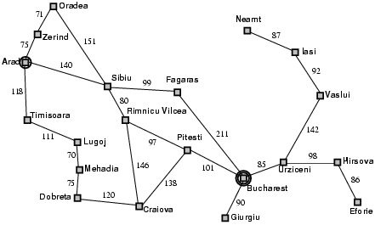

For DFS , the sequence is : Arad -> Sibu -> Fagaras -> Bucharest.
For BFS , the sequence is : Arad -> Zerind -> Sibiu -> Timisoara -> Oradea -> Fagaras -> Riminu Vilecia -> Lugoj -> Bucharest

Conclusion:- In this experiment , we have learnt about graphs as a non linear data structure , which can be used to store data efficiently , and we have learnt about the two types of traversals in a graph ,namely BFS and DFS traversals and we have also learnt how to implement them through code.

